

**THE UNIVERSITY OF TEXAS AT ARLINGTON, TEXAS  
DEPARTMENT OF ELECTRICAL ENGINEERING**

**EE 5356**

**DIGITAL IMAGE PROCESSING**

**PROJECT # 11**

**by**

**SOUTRIK MAITI**

**1001569883**

**Presented to**

**Dr. K.R.RAO**

**April 19, 2019**

**Inverse and Wiener Filter**

***MATLAB Code:***

clc;

clear all;

close all;

%% Reading and displaying the original image

img = imread('lena512.bmp');

%% Doing a FFT and shift in the Fourier Domain

FFT_img = fft2(img);

FFT2_img = fftshift(FFT_img);

%% Initializing the matrices for the Wiener filters

NN = 512; % Size of the matrices

WF_1 = wiener_fil(0.0025);

WF_2 = wiener_fil(0.001);

WF_3 = wiener_fil(0.00025);

%% Making DFT of White Noise matrix of size NN

white_noise = randn(NN,NN);

DFT_white_noise = fft2(white_noise);

DFT_1 = fft2(zeros(512));

DFT_2 = fft2(zeros(512));

DFT_3 = fft2(zeros(512));

%% Images corrupted with white noise for different k in Fourier Domain

G_uv_1 = FFT2_img.*WF_1 + DFT_white_noise;

G_uv_2 = FFT2_img.*WF_2 + DFT_white_noise;

G_uv_3 = FFT2_img.*WF_3 + DFT_white_noise;

%% Taking IFT of the degraded images in the Fourier Domain

deg_img_1 = ifft2(ifftshift(G_uv_1));

deg_img_2 = ifft2(ifftshift(G_uv_2));

deg_img_3 = ifft2(ifftshift(G_uv_3));

%% Displaying Original image and image corrupted with noise

figure(1);

subplot(2,2,1);

imshow(img);

title('original image');

subplot(2,2,2);

imshow(uint8(deg_img_1));

nme_one_1=sprintf('Image degraded for k = 0.0025');

title(nme_one_1);

subplot(2,2,3);

imshow(uint8(deg_img_2));

nme_one_1=sprintf('Image degraded for k = 0.001');

title(nme_one_1);

subplot(2,2,4);

imshow(uint8(deg_img_3));

nme_one_1=sprintf('Image degraded for k = 0.00025');

title(nme_one_1);

%% saving the results

saveas(gca,'white_noise_wf.jpg');

%% Restoring the image with Inverse filter

%% Initializing the inverse filter for different k

iwf_1 = inv_fil_123(WF_1);

iwf_2 = inv_fil_123(WF_2);

iwf_3 = inv_fil_123(WF_3);

%% Filtering the images

id_img_1 = G_uv_1 .* iwf_1;

id_img_2 = G_uv_2 .* iwf_2;

id_img_3 = G_uv_3 .* iwf_3;

%% taking IFT of the filtered images

res_img_1 = ifft2(ifftshift(id_img_1));

res_img_2 = ifft2(ifftshift(id_img_2));

res_img_3 = ifft2(ifftshift(id_img_3));

%% Displaying the results

figure(2);

subplot(2,2,1);

imshow(img);

title('original image');

subplot(2,2,2);

imshow(uint8(res_img_1));

title('Inverse filtering for k = 0.0025');

subplot(2,2,3);

imshow(uint8(res_img_2));

title('Inverse filtering for k = 0.001');

subplot(2,2,4);

imshow(uint8(res_img_3));

title('Inverse filtering for k = 0.00025');

%% saving the results

saveas(gca,'res_img_iwf.jpg');

%% Restoring images with Wiener filter

rtio1=sum(sum(abs(DFT_white_noise)))/sum(sum(abs(DFT_1)))

rtio2=sum(sum(abs(DFT_white_noise)))/sum(sum(abs(DFT_2)))

rtio3=sum(sum(abs(DFT_white_noise)))/sum(sum(abs(DFT_3)))

R_u_1 = zeros(512);

R_u_1 = abs(fftshift(ifft2(fft2(img).*conj(fft2(img)))))./(512^2);

R_n_1 = zeros(512);

R_n_1 = abs(fftshift(ifft2(fft2(white_noise).*conj(fft2(white_noise)))))./(512^2);

S_u_1 = fftshift(fft2(R_u_1));

S_n_1 = fftshift(fft2(R_n_1));

%% Applying Wiener filter with different k in the FD

W_img_1 = conj(WF_1).*S_u_1./((abs(WF_1).^2).*S_u_1+S_n_1);

W_img_2 = conj(WF_2).*S_u_1./((abs(WF_2).^2).*S_u_1+S_n_1);

W_img_3 = conj(WF_3).*S_u_1./((abs(WF_3).^2).*S_u_1+S_n_1);

Inv_1 = G_uv_1.*W_img_1;

Inv_2 = G_uv_2.*W_img_2;

Inv_3 = G_uv_3.*W_img_3;

%% Taking the inverse FT of the filtered images

restrd_img1_mtrx_512_1 = ifft2(ifftshift(Inv_1));

restred_img2_mtrx_512_2 = ifft2(ifftshift(Inv_2));

restred_img3_mtrx_512_3 = ifft2(ifftshift(Inv_3));

%% Displaying the results

figure(3);

subplot(2,2,1);

imshow(img);

title('original image');

subplot(2,2,2);

imshow(uint8(restrd_img1_mtrx_512_1));

title('Wiener Filtering for k = 0.0025');

subplot(2,2,3);

imshow(uint8(restred_img2_mtrx_512_2));

title('Wiener Filtering for k = 0.001');

subplot(2,2,4);

imshow(uint8(restred_img3_mtrx_512_3));

title('Wiener Filtering for k = 0.00025');

%% saving the results

saveas(gca,'res_img_wf.jpg');

%% Functions for this project

%% Algorithm for inverse filter

function [ K ] = inv_fil_123(H1)

e = 0.001;

N_s = 512;

for uu_1 = 1:N_s

for vv = 1:N_s

if(H1(uu_1,vv) < e)

K(uu_1,vv) = 0;

else

K(uu_1,vv) = 1/H1(uu_1,vv);

end

end

end

end

%% Algorithm for wiener filter

function Hh = wiener_fil(k)

N_s = 512;

for uu_11 = 1:N_s

for vv_11 = 1:N_s

Hh(uu_11,vv_11) = exp(-k*((uu_11-N_s/2)^2+(vv_11-N_s/2)^2)^(5/6));

end

end

end

***Results:***

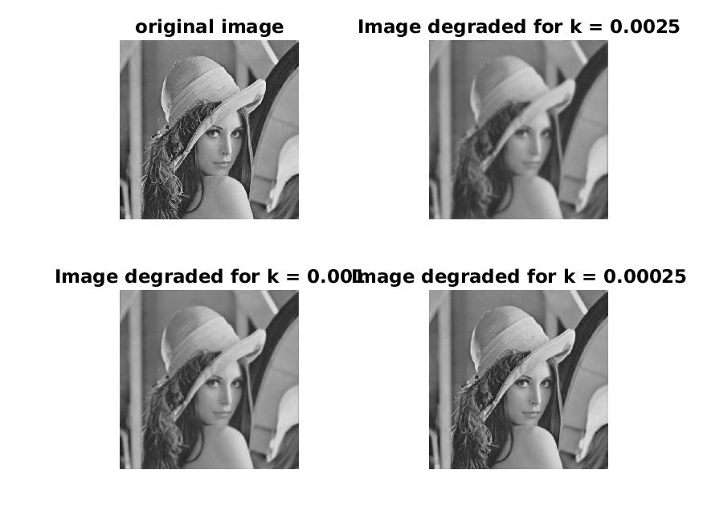

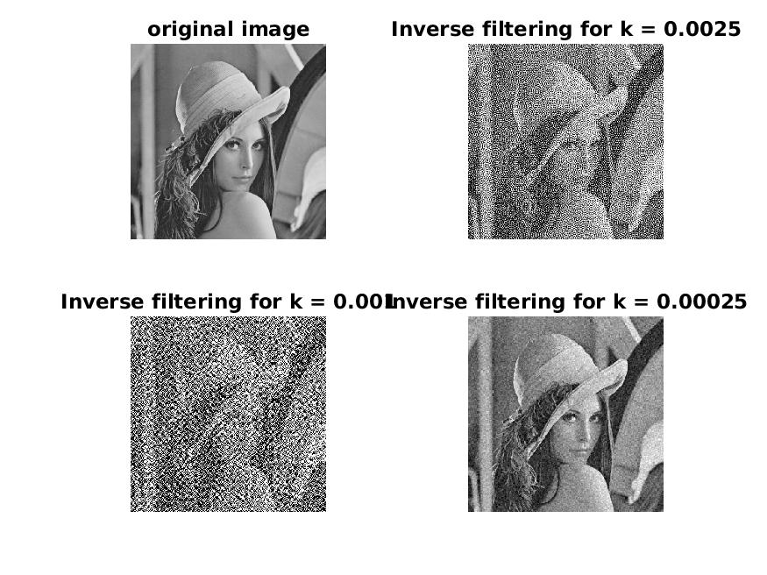

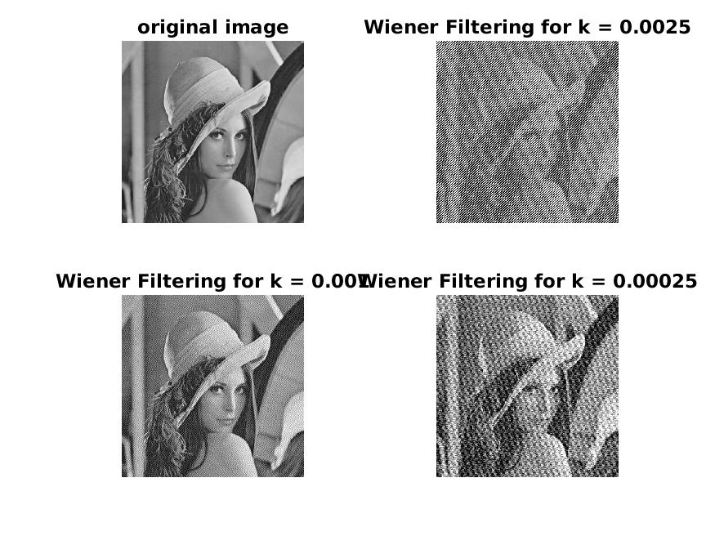

***Conclusion:***

* From the output of a noiseless linear system, the inverse filter restores a blurred image perfectly. But it does not work perform well when there is presence of additive white noise.
* Wiener filtering performs far better in restoring images even in the combination of presence of blur and noise.